**DBMS Mini Project**

**Project Title:**

College Database Management

**Team Members:**

RA1911003011023 (Rishabh Abhani)

RA1911003011026 (Ruchika Goyal)

RA1911003011038 (Shambhavi Jha)

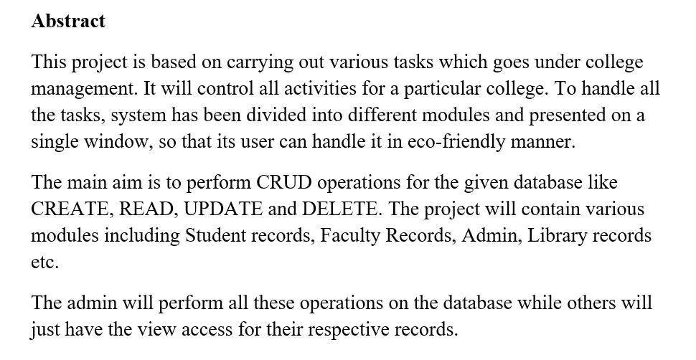

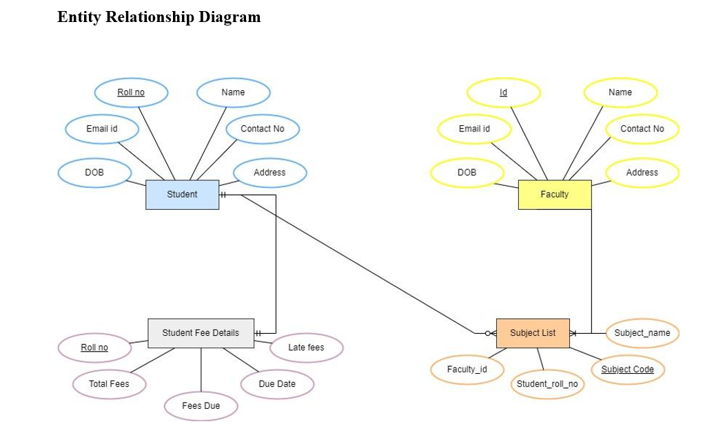

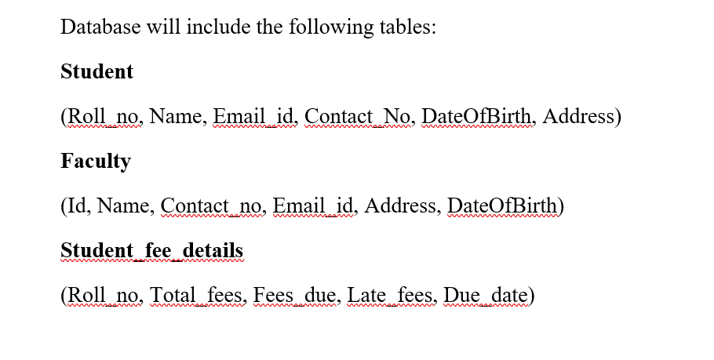

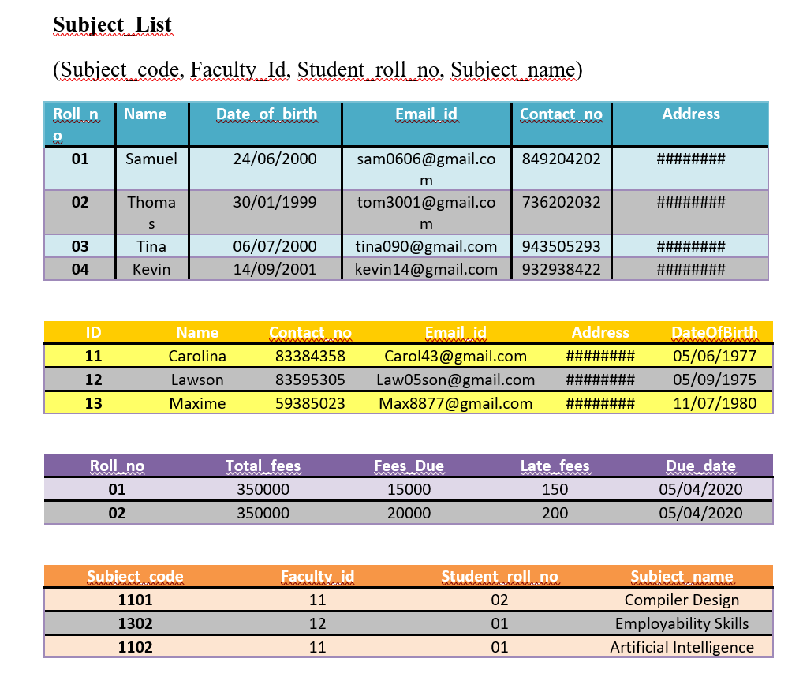

Implementation:

To implement the following requirements are met

College Management System

Technologies Used

1. HTML/CSS as front end.

2. My SQL as back end.

Software Used

1. Windows 11

2. Visual studio

3. My SQL.

Hardware Requirements

Processor – Pentium IV or higher version.

Ram – 100 MB.

Hard Disk – 150 MB.